 | Monday | Tuesday | Wednesday | Thursday | Friday
Content Objective | I can apply my feature writing knowledge to my Thanksgiving student feature article. | I can apply my feature writing knowledge to my Thanksgiving student feature article. |  | Enjoy your Thanksgiving weekend and time with your families! =)
Language Objective | I can write my Thanksgiving feature article. | I can write my Thanksgiving feature article.
Activity | Article brainstorm/pre write | Article writing
Accomm.
Vocabulary
Standard | CCSS.ELA-LITERACY.WHST.6-8.10  Write routinely over extended time frames (time for reflection and revision) and shorter time frames (a single sitting or a day or two) for a range of discipline-specific tasks, purposes, and audiences. | CCSS.ELA-LITERACY.WHST.6-8.10  Write routinely over extended time frames (time for reflection and revision) and shorter time frames (a single sitting or a day or two) for a range of discipline-specific tasks, purposes, and audiences. |  | 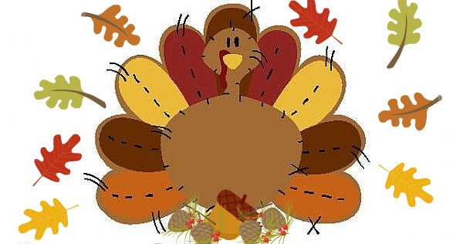
*All plans subject to change at the discretion of the teacher

