 | Monday | Tuesday | Wednesday | Thursday | Friday
Content Objective | I can create a political article on Obama’s farewell speech using my quotes sheet. | I can create a political article on Obama’s farewell speech using my quotes sheet. | I can remember the elements that make a story news-worthy and participate in a class discussion | I can analyze news articles to see what makes them news-worthy by completing a news chart | End of first Semester!  Halfway through the school year! =)
Language Objective | I can write to report my political article using my quotes from Obama’s farewell speech. | I can write to report my political article using my quotes from Obama’s farewell speech. | I can orally have a class discussion about what makes a story news-worthy | I can write to draw conclusions on what makes an article news-worthy | 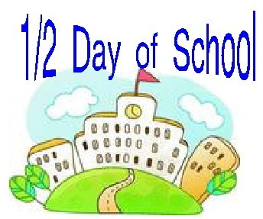
Activity | Political Article | Political Article | News-worthy project | News-worthy project
Accomm.
Vocabulary
Standard | CCSS.ELA-LITERACY.WHST.6-8.1.D  Establish and maintain a formal style. | CCSS.ELA-LITERACY.WHST.6-8.1.D  Establish and maintain a formal style. | CCSS.ELA-LITERACY.WHST.6-8.1.D  Establish and maintain a formal style. | CCSS.ELA-LITERACY.WHST.6-8.1.D  Establish and maintain a formal style. | CCSS.ELA-LITERACY.WHST.6-8.1.D  Establish and maintain a formal style.
*Lessons are subject to change at the discretion of the teacher

