 | Monday  October 30 | Tuesday  October 31 | Wednesday  November 1 | Thursday  November 2 | Friday  November 3
Content Objective | I can understand the 7 Wonders of the Ancient World by outlining each wonder on a project outline. | 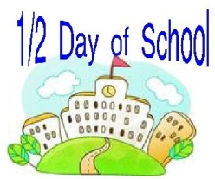 | I can understand the 7 Wonders of the Ancient World by outlining each wonder on a project outline. | I can create my project of 7 Wonders of the Ancient World by designing my travel brochure.
Language Objective | I can write to answer questions about the 7 Wonders of the Ancient World using the frames “This wonder was built in…”, “This wonder was located in…” |  | I can write to answer questions about the 7 Wonders of the Ancient World using the frames “This wonder was built in…”, “This wonder was located in…” | I can write to create my 7 Wonders of the Ancient World project using my brochure template. | End of 1st  Quarter!
Activity
Vocab.
Standard | G1.1.1 Explain and use a variety of maps, globes, and web based geography technology to study the world, including global, interregional, regional, and local scales. |  | G1.1.1 Explain and use a variety of maps, globes, and web based geography technology to study the world, including global, interregional, regional, and local scales. | G1.1.1 Explain and use a variety of maps, globes, and web based geography technology to study the world, including global, interregional, regional, and local scales.
*All plans subject to change at the discretion of the teacher

